**Figure 1**

*Summary Statistics of Numeric Variables in the Dataset.*

**Figure 2**

*Correlation matrix of Numeric Variables in the Final Dataset.*

**Figure 3**

*Pair plot of Key Variables Related to Biological Age.*

**Figure 4**

*Regression results for Research Question 1: Biomarkers only.*

**Figure 5**

*Regression results for Research Question 2: Biomarkers plus lifestyle factors.*

**Figure 6**

*Regression results for Research Question 3: Full model with biomarkers, lifestyle, and health indicators.*

**Figure 7**

*Random Forest Model Results: R² Score, RMSE, MAE, and Top 10 Feature Importance.*

**Figure 8**

*Model performance comparison using R² (blue bars) and RMSE (red line). Bagged Trees and Random Forest outperformed Linear Regression and SVM in predicting biological age.*

**Figure 9**

*Residuals vs. Predicted Values for the Full Model for Linear Regression.*

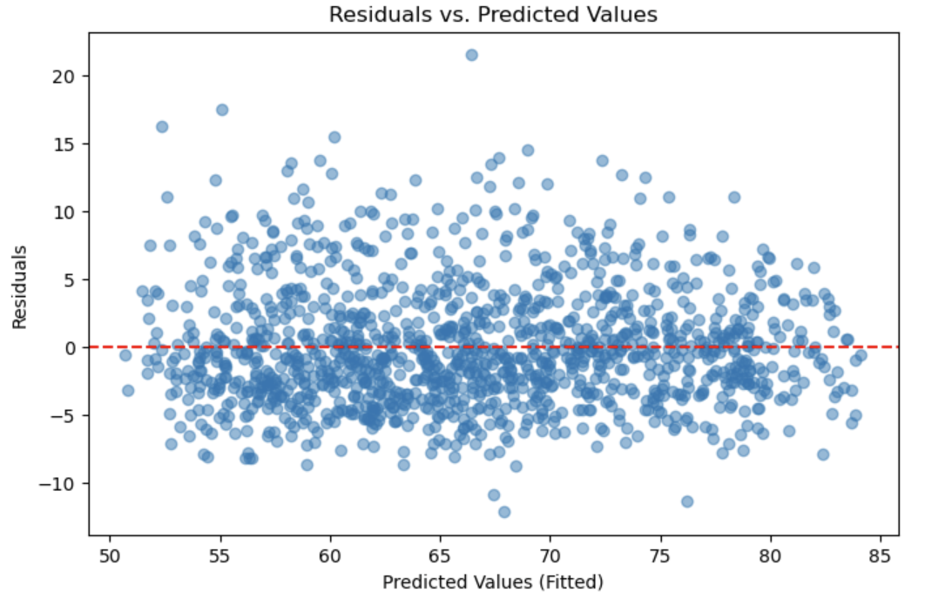

**Figure 10**

*QQ Plot of Residuals for the Full Model for Linear Regression.*

